**10.Develop vector auto regression model for multivariate time**

**series data forecasting.**

**AIM:**

To develop a vector auto regression model for multivariate time series data forecasting using the given dataset.

**PROCEDURE:**

1.Import the necessary libraries:

import pandas as pd

import numpy as np

import matplotlib.pyplot as plt

from statsmodels.tsa.api import VAR

from sklearn.metrics import mean_squared_error

2. Load and preprocess data:

df = pd.read_csv('/content/PRICE_AND_DEMAND_201801_NSW1.csv')

df['SETTLEMENTDATE'] = pd.to_datetime(df['SETTLEMENTDATE'])

df.set_index('SETTLEMENTDATE', inplace=True)

df = df[['TOTALDEMAND', 'RRP']]

df = df.resample('H').mean().dropna()

3.Train-test split:

n_obs = 24 * 7

train, test = df[:-n_obs], df[-n_obs:]

4. Fit the VAR model:

model = VAR(train)

results = model.fit(maxlags=15, ic='aic')

5. Forecast:

lag_order = results.k_ar

forecast_input = train.values[-lag_order:]

forecast = results.forecast(y=forecast_input, steps=n_obs)

forecast_df = pd.DataFrame(forecast, index=test.index, columns=['TOTALDEMAND_forecast', 'RRP_forecast'])

6.  Evaluation:

rmse_demand = np.sqrt(mean_squared_error(test['TOTALDEMAND'], forecast_df['TOTALDEMAND_forecast']))

rmse_rrp = np.sqrt(mean_squared_error(test['RRP'], forecast_df['RRP_forecast']))

print(f'RMSE (Demand): {rmse_demand:.2f}')

print(f'RMSE (RRP): {rmse_rrp:.2f}')

7. Plot results:

plt.figure(figsize=(14, 6))

plt.subplot(2, 1, 1)

plt.plot(test['TOTALDEMAND'], label='Actual Demand')

plt.plot(forecast_df['TOTALDEMAND_forecast'], label='Forecasted Demand')

plt.title('Electricity Demand Forecast')

plt.legend()

plt.subplot(2, 1, 2)

plt.plot(test['RRP'], label='Actual Price')

plt.plot(forecast_df['RRP_forecast'], label='Forecasted Price')

plt.title('Electricity Price Forecast')

plt.legend()

plt.tight_layout()

plt.show()

**OUTPUT:**

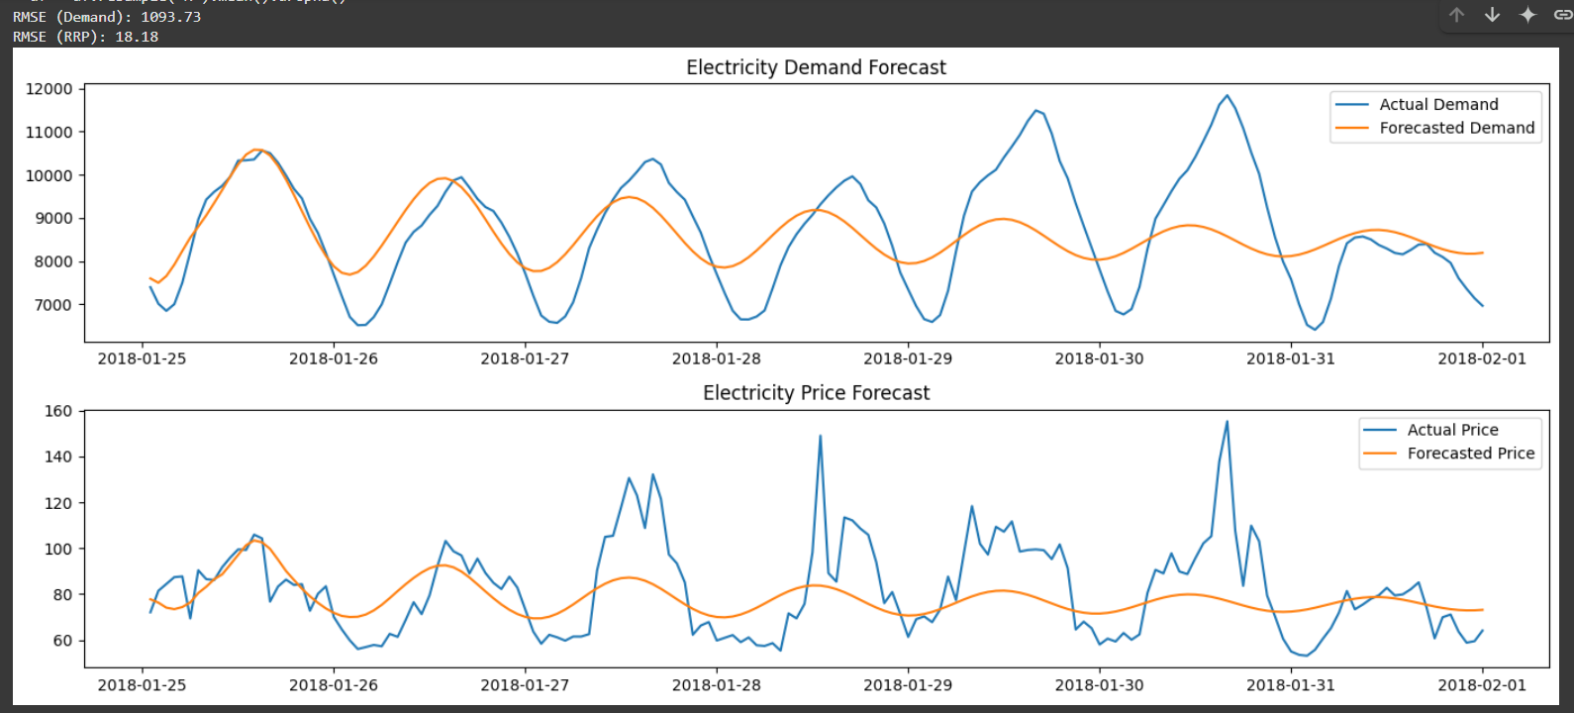

**RESULT:**

Thus the program has been implemented and executed sucessfully.